**MAJOR PROJECT REPORT**

**ON**

**NextGen (E-Commerce)**

*Submitted in partial fulfillment of the requirements*

*for the award of the degree of*

**Master of Computer Applications (MCA)**

Submitted to



**RAJIV GANDHI PROUDYOGIKI VISHWAVIDYALAYA,**

**BHOPAL (M.P.)**

Submitted by

**Zeeshan Khan (0133CA231150)**

**Gaurav Singh Lodhi (0133CA231052)**

**Suraj Vishwas (0133CA231138)**

Under the Guidance of

**Assistant Prof. Aruna Sengar**



**DEPARTMENT OF COMPUTER APPLICATIONS (MCA)**

**SAGAR INSTITUTE OF RESEARCH & TECHNOLOGY, BHOPAL (M.P.)**

**May – 2025**

**DECLARATION**

I hereby declare that the Project synopsis entitled **“NextGen (E-Commerce)"** is my own work conducted under the supervision of **Guide Name, Designation,** Department of Computer Applications (MCA), Sagar Institute of Research & Technology, Bhopal.

I further declare that to the best of my knowledge this report does not contain any part of work that has been submitted for the award of any degree either in this institute or in other institute without proper citation.

**Zeeshan Khan (0133CA231150)**

**Gaurav Singh Lodhi (0133CA231052)**

**Suraj Vishwas (0133CA231138)**

**CERTIFICATE**

## This is to certify that the Major Project titled “ NextGen (E-Commerce)” the Bonafide research work carried out independently by Zeeshan Khan (0133CA231158), Gaurav Singh Lodhi (133CA231052), Suraj Vishwas (0133CA231138) student of MCA Semester IV from SIRT affiliated with Rajiv Gandhi Prodhyogiki Vishvidhayalaya, Bhopal.

*In the partial fulfilment of the requirement for the award of the degree of Master in Computer Application and Project has not formed the basis for the award previously of any degree, diploma, associate ship, fellowship or any other similar title according to my knowledge.*

Guided By: Approved By:

**Prof. Dr. Kapil Chaturvedi**

Dr. Aruna Sengar Head and Associate Professor

Dept. of Computer Applications Dept. of Computer Applications

SIRT, Bhopal. SIRT, Bhopal

Forwarded By

**Dr. Rajiv Srivastava**

Director

SIRT, Bhopal

#### ACKNOWLEDGEMENT

A Journey is easier when you travel together. Interdependence is certainly more valuable than independence. I would like to express my gratitude to all those who gave me the possibility to complete my Dissertation. Above all, I pay gratitude to supreme power **“The Almighty”** who blessed me with patience and vigor to complete this dissertation successfully.

First and foremost, I would like to express my sincere thanks to **Dr. Rajiv Srivastava, Director SIRT Bhopal**, Who Always Encouraged me to achieve new heights, MCA, Is one of them.

I would like to express my sincere regard to **Dr. Kapil Chaturvedi, HOD, MCA, SIRT,** his encouragement and timely suggestions during all academic sessions made this work possible and easy.

I would like to express my deep regards to **Prof. -------------------------------------------------------project Guide** who gave me chance to select the topic and work under with him he gave me moral support which was most valuable during my Work.

I wish to take this opportunity to express my heartily thanks to all faculties of MCA department who helped me in completing my Research work and enlighten my skill by the learning process and knowledge that I came across during the whole span of this Project.

I am sure that this Project work has given me confidence and has prepared me to take new challenging jobs in future.

**Zeeshan Khan (0133CA231150)**

**Gaurav Singh Lodhi (0133CA231052)**

**Suraj Vishwas (0133CA231138)**

**ABSTRACT**

Online Shopping play a great importance in the modern business environment. Dream gate has opened the door of opportunity and advantage to the firms. This paper analyzed the different issue of online shopping. The project aims to provide theoretical contribution in understanding the present status of online shopping. The Study Discuss the consumers’ online shopping behaviors. Paper also identifies the problems face by the consumers when they want to accept internet shopping. Present paper is an expressive study based on the detailed review of earlier pertinent studies related to the various concepts of online shopping to discover the concept of online shopping. Solitude and safety risk emerge regularly as a reason for being cautious about internet shopping. Shopping convenience, information seeking, social contact, and diversity affects the consumer attitude towards online shopping. The impossibility of product testing, problems with complaints, product return and missus of personal data are the main doubts regarding on-line shopping Keywords E-Commerce is now seen as a reality for many businesses and a normal part of a business plan. The immediate benefits, in terms of cost savings, efficiencies and enhanced profitability are clear at every stage in the supply chain. Adopting e-business is no longer a competitive advantage, but a normal business process, without which an enterprise is unlikely to survive in the new economy. Year 2000 saw many Dot-com companies built up and many companies going into E-commerce however now it is a different story, more and more companies are failing, and investors are becoming cautious to invest money into Internet ventures.

**Table of content**

|  |  |  |
| --- | --- | --- |
| **S.No.** | **Content** | **Page No** |
|  | **Chapter 1- Introduction** |  |
| 1.1 | Objective/ Purpose |  |
| 1.2 | Problem definition |  |
| 1.3 | Scope |  |
| 1.4 | Technologies Used |  |
|  | 1.4.1 Software Requirements |  |
|  | 1.4.2 Hardware Requirements |  |
|  | **Chapter 2- Software Requirement Specifications** |  |
| 2.1 | Introduction |  |
| 2.2 | 2 Overall Description |  |
| 2.3 | System Features & Feasibility study |  |
| 2.4 | System models |  |
|  | 2.4.1 Scenarios |  |
|  | 2.4.2 Software Development Model |  |
|  | 2.4.3 Use Case Model Description |  |
|  | 2.4.4 Class diagrams |  |
|  | 2.4.5 Activity Diagrams |  |
| 2.5 | Nonfunctional Requirements |  |
|  | 2.5.1 Performance Requirements |  |
|  | 2.5.2 Security / Safety Requirements |  |
|  | **Chapter 3- System Design** |  |
| 3.1 | Design Methodology |  |
| 3.2 | Entity Relationship Diagram |  |
| 3.3 | Flowcharts |  |
| 3.4 | Databse Design |  |
| 3.5 | DFD *( show different levels of DFDs)* |  |
| 3.6 | Data Dictionary |  |
| 3.7 | Snaps of functions or Screen (With description) |  |
| 3.8 | Testing |  |
|  | **Chapter 4- Conclusions and future scope** |  |
| 4.1 | Conclusion (with Applications/ utility) |  |
| 4.2 | Future Scope |  |
|  | **REFERENCES** |  |
|  |  |  |

CHAPTER-1

INTRODUCTION

**Chapter-1**

**Introduction**

* 1. **INTRODUCTION –**

An E-commerce website requires appropriate strategy of successful design and implementation. Everything is required to plan from scratch to end of website. The e-commerce sector is seen the exponential growth thus a new option will easily part of this regatta of commercial website. The ecommerce website will feature the online shopping facility of various fashion products under a single web space. The proposed web application will allow business personnel to make their total business using it and increase their reachability thousands of times more than today they have, over the internet. It will allow multiple shopping vendors to sale their products online. The product management in the system will be done in the form of categories. The safety of information is the main requirement of the system and will be handling according to that. To formulate this project first task is to do is cost estimation. For probabilistic assessment of the project cost estimation is required. Cost estimation covers the accurate; estimations of cost and effort required for the project. As a project manager and developer as well, it’s is estimates are defined to early stage in the project. Cost estimation in application development project includes the set of procedures and techniques that will be utilized, required to produce by organisation for development The available resources of a company are also affecting the cost estimation. It will be very complex project. To demonstrate knowledge learnt in class, tech communities and online materials, The environment variants depend on the further requirements of the ecommerce web application.

* 1. **Objective –**

Online Shopping play a great importance in the modern business environment. Dream gate has opened the door of opportunity and advantage to the firms. This paper analysed the different issue of online shopping. The project aims to provide theoretical contribution in understanding the present status of online shopping. The Study Discuss the consumers’ online shopping behaviours. Paper also identifies the problems face by the consumers when they want to accept internet shopping. Present paper is an expressive study based on the detailed review of earlier pertinent studies related to the various concepts of online shopping to discover the concept of online shopping. Solitude and safety risk emerge regularly as a reason for being cautious about internet shopping. Shopping convenience, information seeking, social contact, and diversity affects the consumer attitude towards online shopping. The impossibility of product testing, problems with complaints, product return and missus of personal data are the main doubts regarding on-line shopping.

**Keywords:**

E-Commerce is now seen as a reality for many businesses and a normal part of a business plan. The immediate benefits, in terms of cost savings, efficiencies and enhanced profitability are clear at every stage in the supply chain. Adopting e-business is no longer a competitive advantage, but a normal business process, without which an enterprise is unlikely to survive in the new economy. Year 2000 saw many Dot-com companies built up and many companies going into E-commerce however now it is a different story, more and more companies are failing, and investors are becoming cautious to invest money into Internet ventures.

* 1. **PURPOSE & SCOPE**–

**Purpose –**

Purpose Traditionally, customers are used to buying the products at the real, in other words factual shops or supermarkets. It needs the customers to show up in the shops in person, and walk around different shopping shelves, and it also needs the owners of shops to stock, exhibit, and transfer the products required by customers. It takes labour, time and space to process these operations. Furthermore, the spread of the Covid-19 pandemic has caused a lot of changes in our lifestyle, people fearing to get outside their homes, transportation almost shut down and social distancing becoming all the more important. Big to small scale business that relied on the traditional incur a lot of consequence due to the lockdown issues. Some tend to more towards using social media platforms like Facebook to sell their product. However, the social media platforms have been beneficial for marketing purposes alone but leaves the whole task of customer and massive order management via direct messaging.

**Scope –**

Dream gate system provides a solution to reduce and optimize these expenses. Authorized Customers do not need to go to the factual shops to choose, and bring the products they need by hands. They simply browse their Personal computers or cell phones to access shops, and evaluate the products description, pictures on the screen to choose products. In addition, the owners of the shop do not need to arrange or exhibit their stocks products. They just input the description, prices of products, and upload their pictures. Simply, both customers and shop owners do not need to touch the real products in the whole process of shopping, and management. In the end the logistic centre will distribute the products required by customers, or products ordered by shop owners to their locations. The customers are able to track the status of their orders until delivery, after which they can leave a review of the type of service they received

CHAPTER-2

**System Analysis**

**Chapter-2**

**System Analysis**

As far as the project is developed the functionality is simple, the objective of the proposal is to strengthen the functioning of Audit Status Monitoring and make them effective and better. The entire scope has been classified into five streams knows as Coordinator Level, management Level, Auditor Level, User Level and State Web Coordinator Level. The proposed software will cover the information needs with respect to each request of the user group viz. accepting the request, providing vulnerability document report and the current status of the audit.

**Existing System–**

Existing System In the existing system, each task is carried out manually and processing is also a tedious job. In previous system travellers were maintaining time table details manually in pen and paper, which was time taking and costly. The travellers is not able to achieve its need in time and also the results may not accurate. Because of the manual maintenance there are number of difficulties and drawbacks exist in the system. Some of them are Drawbacks of the Existing System:

• Increased transaction leads to increased source document and hence maintenance becomes difficult.

• If any admin, user entry is wrongly made then the maintenance becomes very difficult.

**Purposed System –**

Reports said that customers can take enjoy online shopping for 24 hour per day. Consumers can purchase any goods and services anytime at everywhere. Online shopping is user friendly compare to in store shopping because consumers can just complete his requirements just with a click of mouse without leaving their home.

• Online shopping has some advantages like below Save the Time of the consumers.

• They can purchase any time from anywhere.

• They can compare the price with the others retailers very easily.

• Compare the advertising price and actual price.

• They can easily track their product

• They can use cash back policy

• They can purchase the product from the foreign marketers

**Minimum Hardware/Software Requirements**

Developer-Side:

* Hardware:

Processor: Intel Core i3 or above

RAM: 4 GB or above

Hard Disk: 50 GB

Display: 1366x768 resolution minimum

Internet Connection: Required for deployment

* Software:

OS: Windows, MacOS, or Linux

Browser: Latest version of Chrome, Firefox, or Edge

Code Editor: VS Code, Sublime Text, or Atom

Customer-Side:

* Hardware:

Any device that supports a modern web browser.

* Software:

Browser: Latest version of Chrome, Firefox, Safari, or Edge

**Justification of Selection of Technology**

The following is the desired functionality of the new system. The proposed project would cover:

Admin Module

* Create and manage categories like "Electronics" and their subcategories such as "TVs" and "Laptops".
* Verify retailer registrations to ensure the authenticity of sellers.
* Maintain a record of retailer activities and generate reports.
* Manage platform-wide data such as customer details, transaction logs, and product inventories.

Retailer Module

* Registration and login functionality for retailers with email and OTP verification.
* Add products with fields for title, description, price, stock, and images.
* Update product details and manage stock levels dynamically.
* View and analyze sales reports to track revenue and order trends.

Customer Module

* Allow customers to register/login securely with encryption.
* Enable browsing of categories, subcategories, and detailed product pages.
* Add products to the cart and place orders seamlessly.
* Provide a secure payment gateway for completing purchases.

CHAPTER-3

**System Design**

**Chapter-3**

**System Design**

**Module Division**

The module division contains the following things:

•Login Page: The login page contains the username and the password.

•Sign up Page: If the user is new to the application, sign up page will open for them.

•Forget Password: After sign up, suppose you forget your password that get, password recovery page will open.

•Loading frame: After Sign in, a loading frame will pop-up on the screen.

•Dashboard: Main frame of the Project will open – It is basically the dashboard from where the whole project will be processed.

•Payment: There will be a payment gateway in order to make the payment of the Booking.

**Data Dictionary**

A Data Dictionary is a collection of names, definitions, and attributes about data elements that are being used or captured in a database, information system, or part of a research project. Data dictionary, or metadata repository, as defined in the IBM Dictionary of Computing, is a "centralized repository of information about data such as meaning, relationships to other data, origin, usage, and format". Oracle defines it as a collection of tables with metadata.

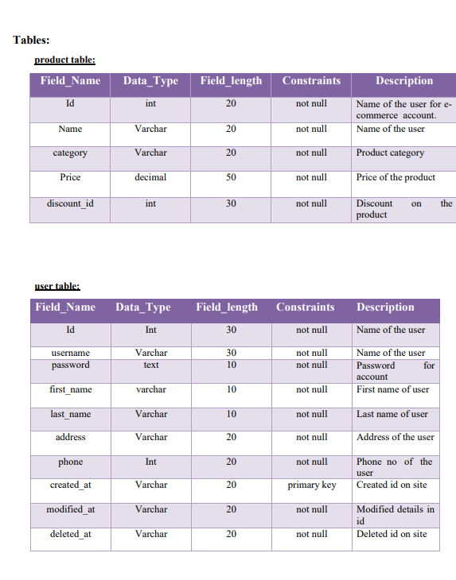

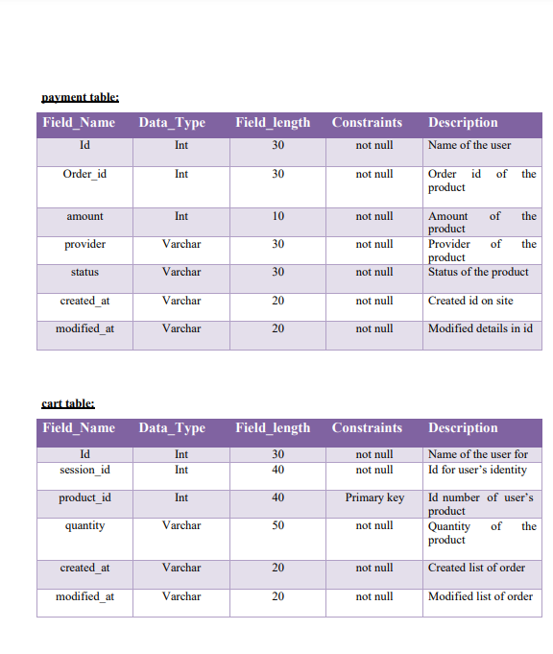

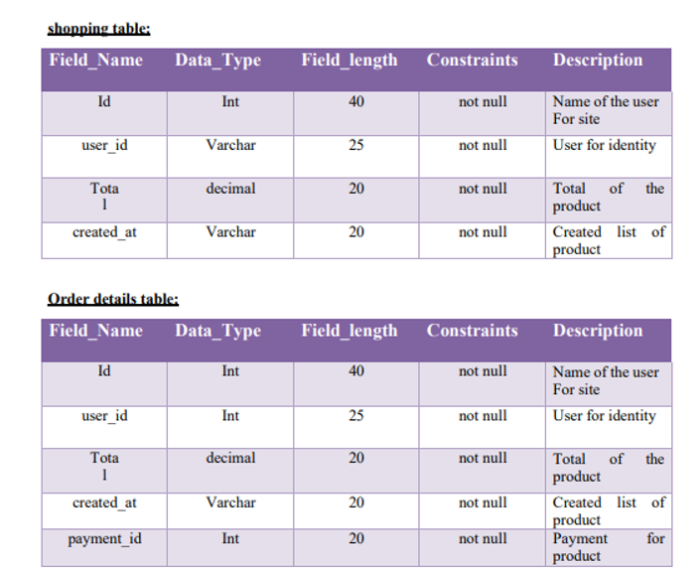

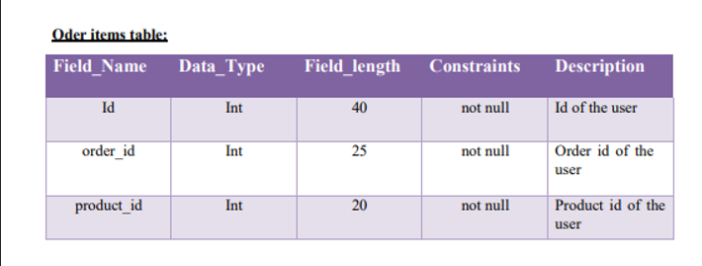

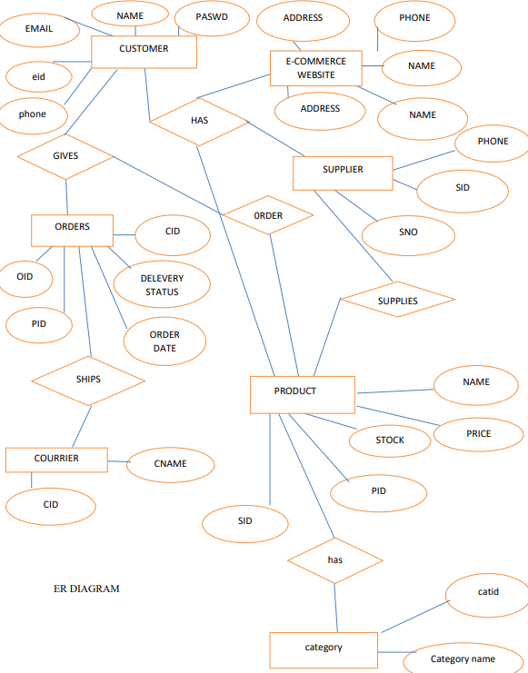

**DATABASE NORMALIZATION –**

**Normalization** is a database design technique that reduces data redundancy and eliminates undesirable characteristics like insertion, update and Deletion Anomalies. Normalization rule divides larger tables into smaller tables and link them using relationships. The purpose of Normalization in SQL is to eliminate redundant (repetitive) data and ensure data is stored logically.

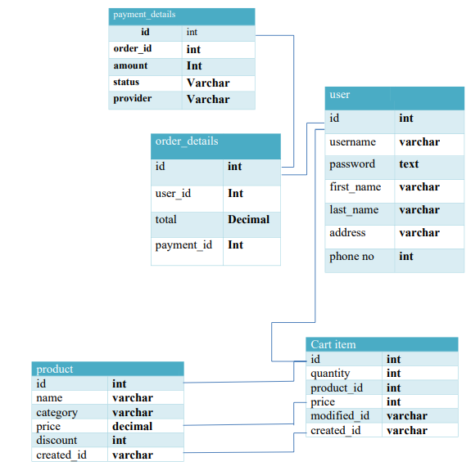

* 1. **DATA FLOW DIAGRAM ( DFD ) –**

A data flow diagram is graphical tool used to describe and analyze movement of data through a system. These are the central tool and the basis from which the other components are developed. The transformation of data from input to output, through processed, may be described logically and independently of physical components associated with the system. These are known as the logical data flow diagrams. The physical data flow diagrams show the actual implements and movement of data between people, departments and workstations.

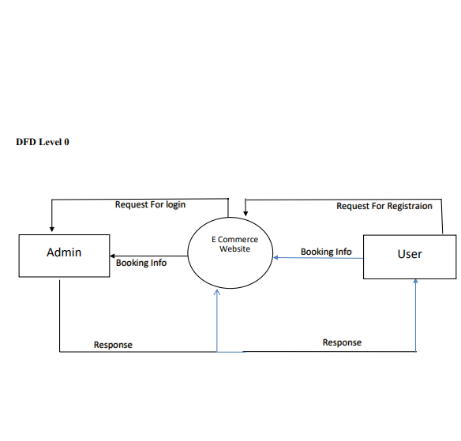

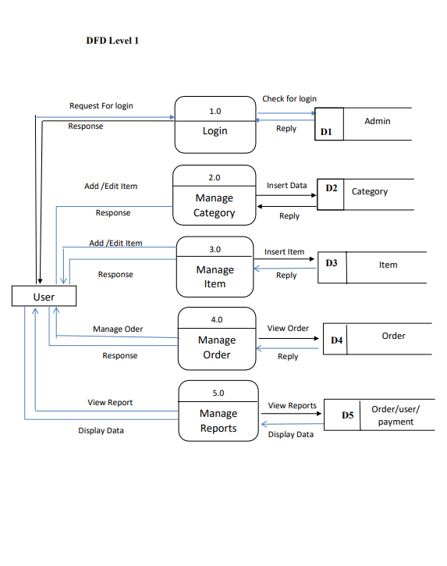

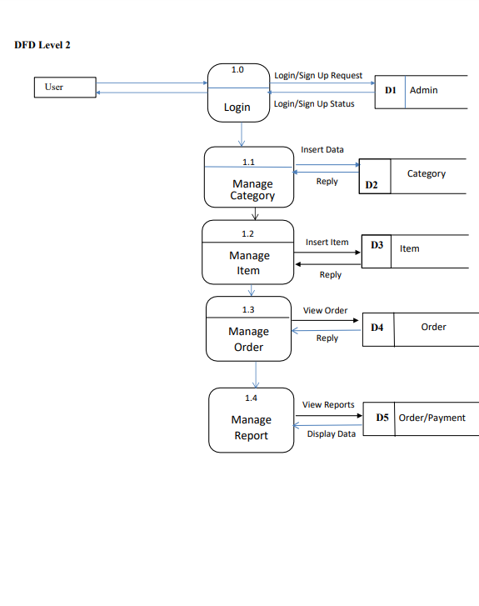

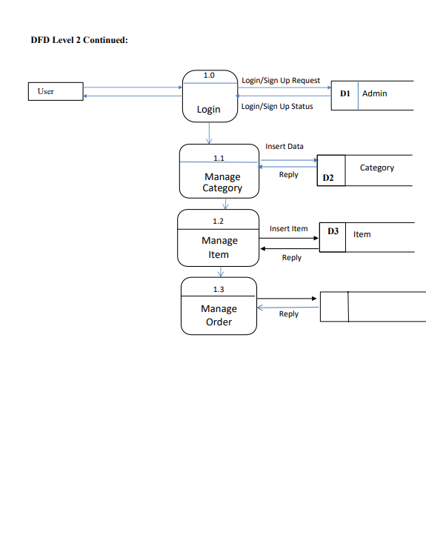

CHAPTER-4

**Implementation**

**& Testing**

**Chapter-4**

**Implementation & Testing**

**Implementation & Testing**

Software testing is a critical phase in the **E-commerce Platform** development process, ensuring that all components work as intended, meet performance requirements, and provide a seamless user experience. Testing includes **unit testing, integration testing, and system testing**, covering various functionalities such as user authentication, product management, order processing, and payment integration.

**Unit Testing**

Unit testing focuses on verifying individual components or modules of the **E-commerce Platform** in isolation. This is particularly important for:

* **Admin Module:** Ensuring that category and subcategory management works correctly.
* **Retailer Module:** Verifying product addition, stock updates, and retailer verification.
* **Customer Module:** Checking login, product browsing, cart management, and order placement functionalities.
* **Payment Gateway:** Testing transactions, payment validation, and order confirmation workflows.

**Testing Approach:**

* **White Box Testing** was used to ensure that all logical conditions and independent paths were executed.
* Automated testing tools like **Jest (for JavaScript-based backend)** and **Mocha** were used to test API responses.
* Each function was tested with valid and invalid inputs to verify robustness.

**White Box Testing**

White box testing was used to verify that all internal operations function as expected. Key aspects tested:

* **All independent paths** in the authentication, product management, and order processing modules were tested at least once.
* **Logical conditions** (such as stock availability checks and payment verification) were tested on both their true and false outcomes.

Example:

* The **login function** was tested for various conditions: correct credentials, incorrect credentials, non-existent users, and blocked users.
* The **product search feature** was tested to ensure accurate results for different keywords and filters.

**Data Flow Testing**

This method ensures proper handling of variables and data throughout the system. It was used to track:

* **User sessions** (ensuring login states are correctly maintained)
* **Cart updates** (ensuring item additions/removals are reflected correctly)
* **Stock changes** (verifying that stock decreases upon order placement)

**Example:**  
If a customer places an order, the system must correctly update:

* Order history for the customer
* Stock quantity for the retailer
* Payment status for transaction tracking

**Loop Testing**

Since loops are extensively used in functionalities like **product listings, order history, and search filters**, loop testing was conducted as follows:

* **Testing loops at boundaries** (e.g., displaying exactly 10 products per page).
* **Skipping loops to test edge cases** (e.g., zero products in the cart).
* **Nested loop testing for product sorting** (ensuring sorting works correctly with various filters applied)

**Integration Testing**

Integration testing was conducted to ensure different modules work together correctly. The **flow graph technique** was used to test:

* **Admin-Retailer interaction**: Retailers submit products, and admins approve listings.
* **Customer-Payment Gateway integration**: Customers place orders, triggering payment verification.
* **Retailer-Stock Management integration**: When stock reaches zero, new orders should be restricted.

The **Cyclomatic Complexity** formula was used to determine test cases:

V(G)=E−N+2V(G) = E - N + 2V(G)=E−N+2

Where:

* **V(G)** = Cyclomatic Complexity
* **E** = Number of Edges
* **N** = Number of Nodes

This helped identify **critical paths** in **checkout, payment, and order confirmation workflows**.

CHAPTER-5

**Challenges Faced**

**Chapter-5**

**Challenges Faced**

**Challenges Faced**

Developing an **E-commerce Platform** is a complex task involving multiple components, including **user authentication, product management, order processing, payment integration, and security enforcement**. Throughout the project, we encountered several challenges that required innovative solutions to ensure a smooth and efficient user experience.

**1. Complex Database Design & Management**

**Challenge:**

* Managing **multiple user roles** (Admin, Retailers, Customers) while ensuring **data consistency**.
* Handling a **large volume of products, orders, and transactions** efficiently.
* Ensuring **real-time stock updates** when multiple users purchase the same product.

**Solution:**

* Used a **relational database (MySQL)** for structured data like user authentication and orders.
* Implemented **MongoDB (NoSQL)** for flexible product listings and faster queries.
* Used **transactions in SQL** to prevent inconsistencies during simultaneous purchases.
* Implemented **caching (Redis)** to reduce database load for frequently accessed data.

**2. Implementing an Effective Search & Filtering System**

**Challenge:**

* Users needed **real-time product searches** based on multiple criteria (e.g., price, category, brand).
* **Database queries were slow** when filtering products due to large datasets.

**Solution:**

* Used **Elasticsearch** for fast, full-text search and filtering.
* Optimized SQL queries with **indexes** to reduce query execution time.
* Added **debouncing in frontend searches** to limit API calls.

**3. Managing User Experience (UX) & Customer Satisfaction**

**Challenge:**

* **Cart abandonment** was high due to a complicated checkout process.
* Customers needed **order tracking and notifications** to stay informed.

**Solution:**

* Simplified the checkout process to **three steps (Cart → Payment → Order Confirmation)**.
* Integrated **email & SMS notifications** for real-time order updates.  
  Added **guest checkout** to allow purchases without mandatory account creation.

**4. Synchronizing Admin & Retailer Operations**

**Challenge:**

* Retailers needed an **easy-to-use dashboard** for product management.
* Admins had to **verify retailers and approve products manually**, causing delays.

**Solution:**

* Developed a **separate retailer dashboard** with real-time analytics.
* Automated **retailer verification process** using AI-based document scanning.
* Created a **bulk upload feature** for retailers to add multiple products at once.

CHAPTER-6

**Conclusion & Future Scope**

**Chapter-6**

**Conclusion & Future Scope**

**Conclusion**

The **NextGen E-commerce Platform** has been successfully developed, providing a **robust, scalable, and user-friendly** solution for online shopping. The system seamlessly integrates **admin, retailer, and customer functionalities**, allowing efficient product management, secure transactions, and a smooth shopping experience. With features such as **secure authentication, product categorization, real-time stock updates, and payment gateway integration**, the platform ensures reliability and efficiency.

Throughout the development of this project, we gained extensive knowledge in **full-stack web development**, covering **React.js for frontend, Node.js and Express.js for backend, and MongoDB/MySQL for database management**. The implementation of **security protocols, caching mechanisms, and database optimizations** enhanced the system's **performance and data integrity**. By following a structured **Software Development Life Cycle (SDLC)**, we were able to efficiently design, implement, and test the system, ensuring high functionality and usability.

The **NextGen platform** provides a strong foundation for future enhancements. Features such as **AI-powered product recommendations, voice search, real-time delivery tracking, and multi-vendor support** can further enhance its capabilities. Additionally, implementing **blockchain-based transactions** will increase security, making the system more resilient against fraud. As e-commerce continues to evolve, **NextGen is well-positioned to adapt and scale**, ensuring a future-proof and competitive solution in the digital marketplace.

This project has been an invaluable learning experience, allowing us to **apply theoretical concepts to real-world development**. It has strengthened our technical skills, problem-solving abilities, and understanding of modern e-commerce systems. Moving forward, **continuous improvements and advanced technology integrations** will ensure that **NextGen remains a cutting-edge platform**, delivering an exceptional online shopping experience for users worldwide.

**Future Enhancements & Scope**

The **NextGen E-commerce Platform** has been designed to be **scalable, secure, and user-friendly**, catering to the needs of **admins, retailers, and customers**. However, with **continuous technological advancements and evolving user expectations**, several **enhancements** can be integrated into the system to **improve functionality, security, and user experience**.

**1. AI-Based Product Recommendations**

**Scope:**

* Personalizing the **shopping experience** by recommending products based on user behavior, past purchases, and browsing history.

**Enhancement Plan:**

* Implement **Machine Learning (ML) algorithms** to analyze customer preferences.
* Use **collaborative filtering techniques** to suggest products similar to those purchased by users with similar profiles.
* Display **trending and popular products** dynamically based on sales data.

**2. Multi-Vendor Marketplace Expansion**

**Scope:**

* Transforming **NextGen** into a **multi-vendor** e-commerce platform where multiple retailers can sell their products.

**Enhancement Plan:**

* Implement **individual seller dashboards** for order tracking, sales analytics, and customer interactions.
* Enable **rating and review systems** for retailers to build trust and transparency.
* Introduce **commission-based earnings** for NextGen from each sale.

**3. Augmented Reality (AR) Shopping Experience**

**Scope:**

* Enhancing customer engagement by allowing **virtual product previews** before purchasing.

**Enhancement Plan:**

* Implement **AR technology** for categories like fashion, furniture, and home decor, enabling customers to "try before they buy."
* Develop an **AR-based mobile app** to allow users to **visualize products in real-world environments**.
* Use **3D modelling** to enhance product descriptions.

**4. Advanced Order Tracking & Delivery Integration**

**Scope:**

* Providing **real-time tracking** of orders and **integrating third-party delivery services** (like Delivery, Blue Dart, etc.).

**Enhancement Plan:**

* Implement **live GPS tracking** for deliveries.
* Integrate **automated SMS/email notifications** for order status updates.
* Enable customers to **select delivery slots** and **reschedule orders**.

**5. Voice Search & Chatbot Assistance**

**Scope:**

* Improving accessibility and customer support with **voice commands** and **AI-driven chatbots**.

**Enhancement Plan:**

* Implement **Natural Language Processing (NLP)-based voice search** for faster product discovery.
* Develop an **AI chatbot** for instant support, order tracking, and FAQs.
* Provide **multilingual support** to cater to diverse user demographics.

**6. Blockchain-Based Payment Security**

**Scope:**

* Ensuring **ultra-secure** transactions using **blockchain technology**.

**Enhancement Plan:**

* Implement **blockchain smart contracts** for transparent and tamper-proof transactions.
* Allow cryptocurrency payments like **Bitcoin, Ethereum, or stablecoins**.
* Enhance **customer trust** with a **decentralized payment ledger**.

**7. Subscription-Based Shopping Model**

**Scope:**

* Offering customers a **subscription model** for exclusive discounts, early access to sales, and priority delivery.

**Enhancement Plan:**

* Introduce **monthly/annual membership plans**.
* Provide **loyalty points and rewards** for repeat customers.
* Enable **auto-renewal for essential products (groceries, cosmetics, etc.)**.

**8. Global Expansion & Multi-Currency Support**

**Scope:**

* Expanding NextGen to **international markets** with multi-currency and multi-language support.

**Enhancement Plan:**

Integrate **currency converters** to display localized pricing.  
Implement **multi-language support** for different regions.  
Partner with **global shipping providers** for worldwide delivery.

**9. Social Media & Influencer Marketing Integration**

**Scope:**

* Allowing customers to purchase products directly via **social media platforms** (Instagram, Facebook, TikTok, etc.).

**Enhancement Plan:**

* Enable **social media login and product sharing**.
* Partner with **influencers for affiliate marketing and brand promotion**.  
  Provide **discounts for social media referrals**.

**10. AI-Powered Fraud Detection & Prevention**

**Scope:**

* Protecting NextGen from **fraudulent transactions, fake reviews, and unauthorized access**.

**Enhancement Plan:**

* Use **AI-driven fraud detection models** to identify suspicious activities.
* Implement **biometric authentication (Face ID, fingerprint login)** for enhanced security.
* Monitor **fake reviews and bot activities** using AI-powered moderation.

**Reference**

**Reference**



**References**

1. **Official Documentation & Technologies Used**
   * React.js Documentation – <https://react.dev/>
   * Node.js Documentation – https://nodejs.org/en/docs/
   * Express.js Documentation – <https://expressjs.com/>
   * MongoDB Documentation – <https://www.mongodb.com/docs/>
   * MySQL Documentation – <https://dev.mysql.com/doc/>
   * Tailwind CSS – <https://tailwindcss.com/docs>
   * JWT Authentication – https://jwt.io/introduction/
   * Payment Gateway API (Razorpay, PayPal, Stripe) – https://razorpay.com/docs/, https://developer.paypal.com/docs/, <https://stripe.com/docs>
2. **Software Development & Security Practices**
   * OWASP Security Guidelines – <https://owasp.org/>
   * Web Security Best Practices – <https://developer.mozilla.org/en-US/docs/Web/Security>
3. **Performance Optimization & Scalability**
   * Caching Strategies (Redis) – https://redis.io/documentation
   * Content Delivery Networks (CDN) – https://www.cloudflare.com/learning/cdn/what-is-a-cdn/
4. **E-Commerce Industry Research & Trends**
   * Global E-commerce Statistics & Trends – https://www.statista.com/topics/871/online-shopping/
   * Future of Online Retail – https://www.forrester.com/research/online-retail/Bottom of Form

**Coding**

**Retailor Dashboard**

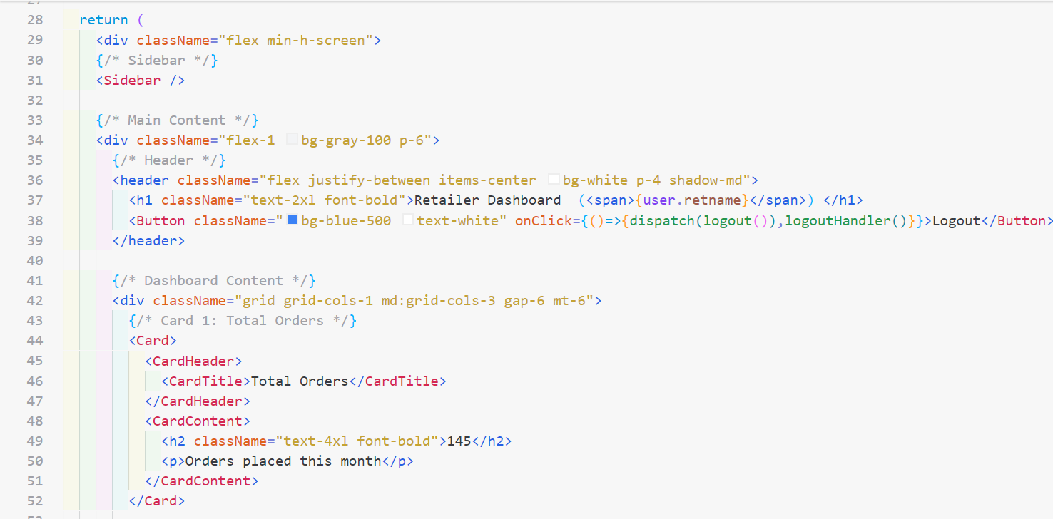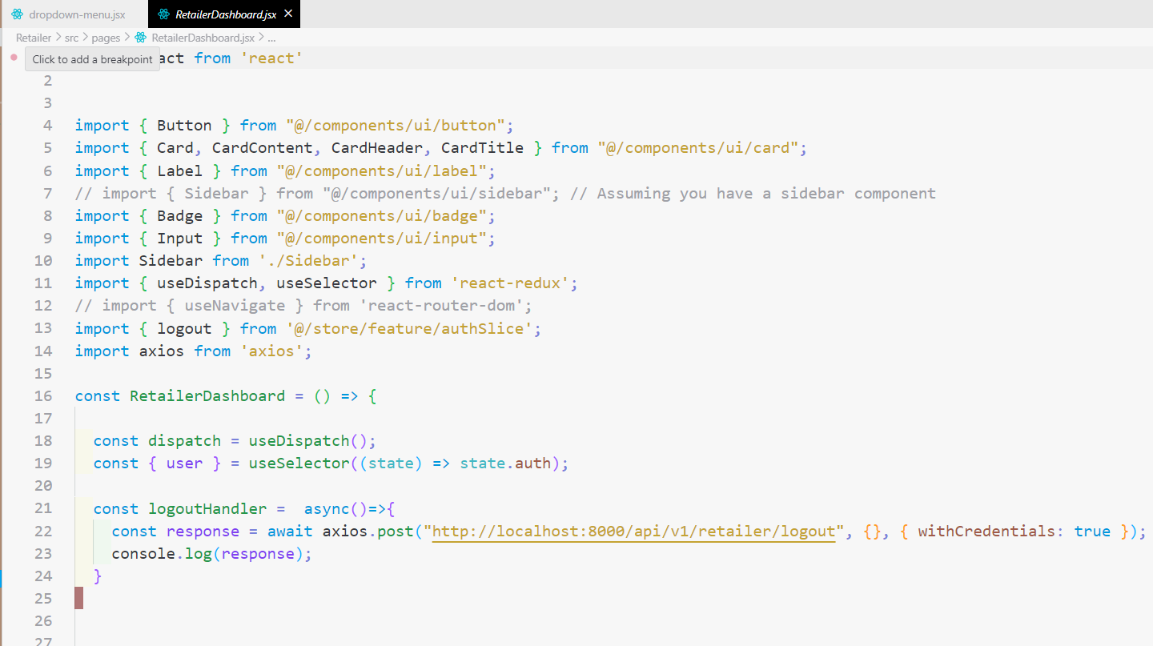

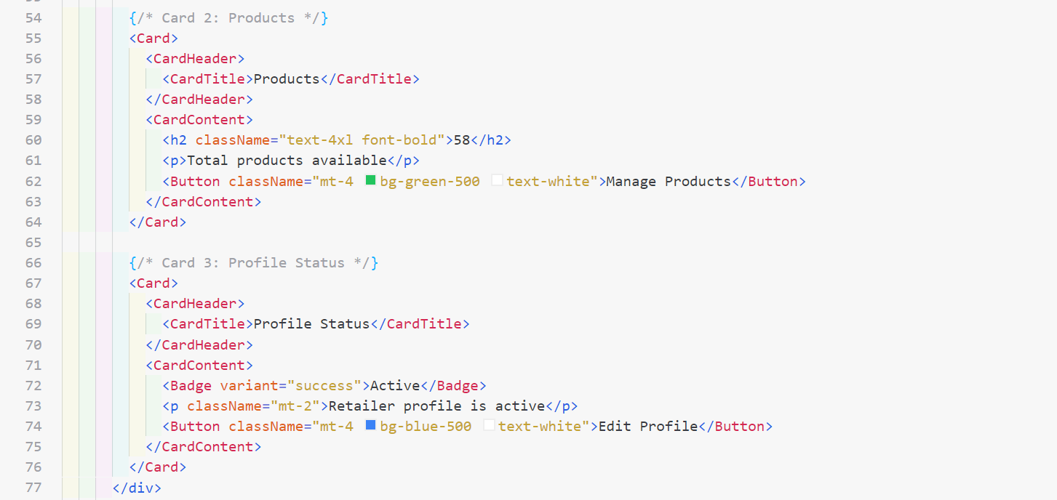

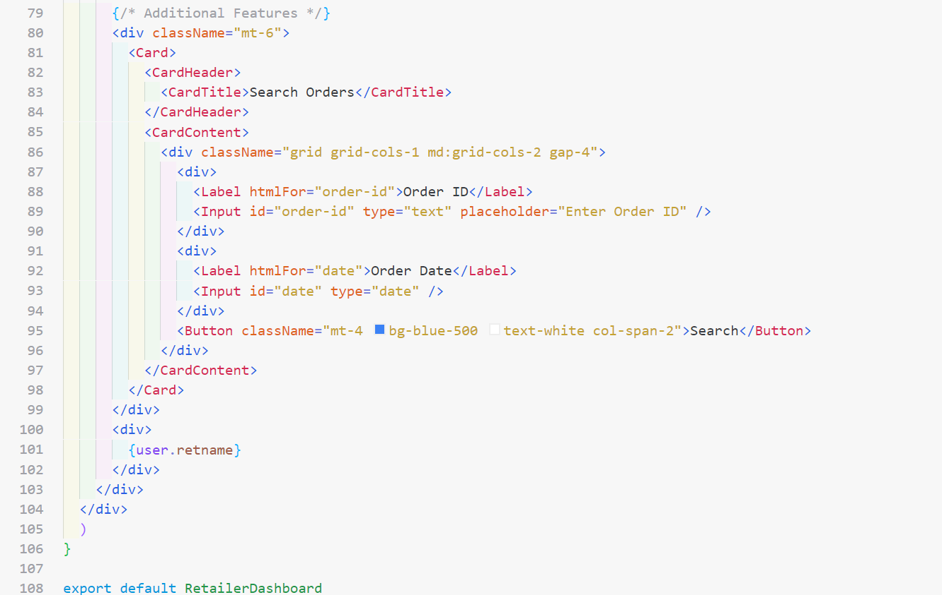

**Retailor sign-up**

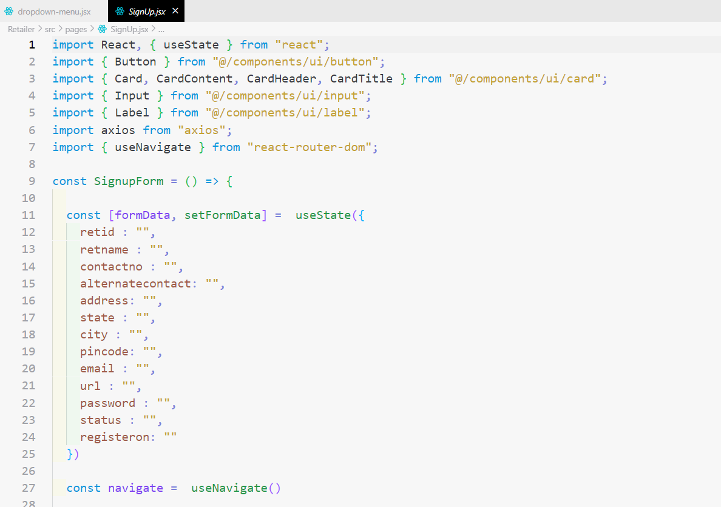 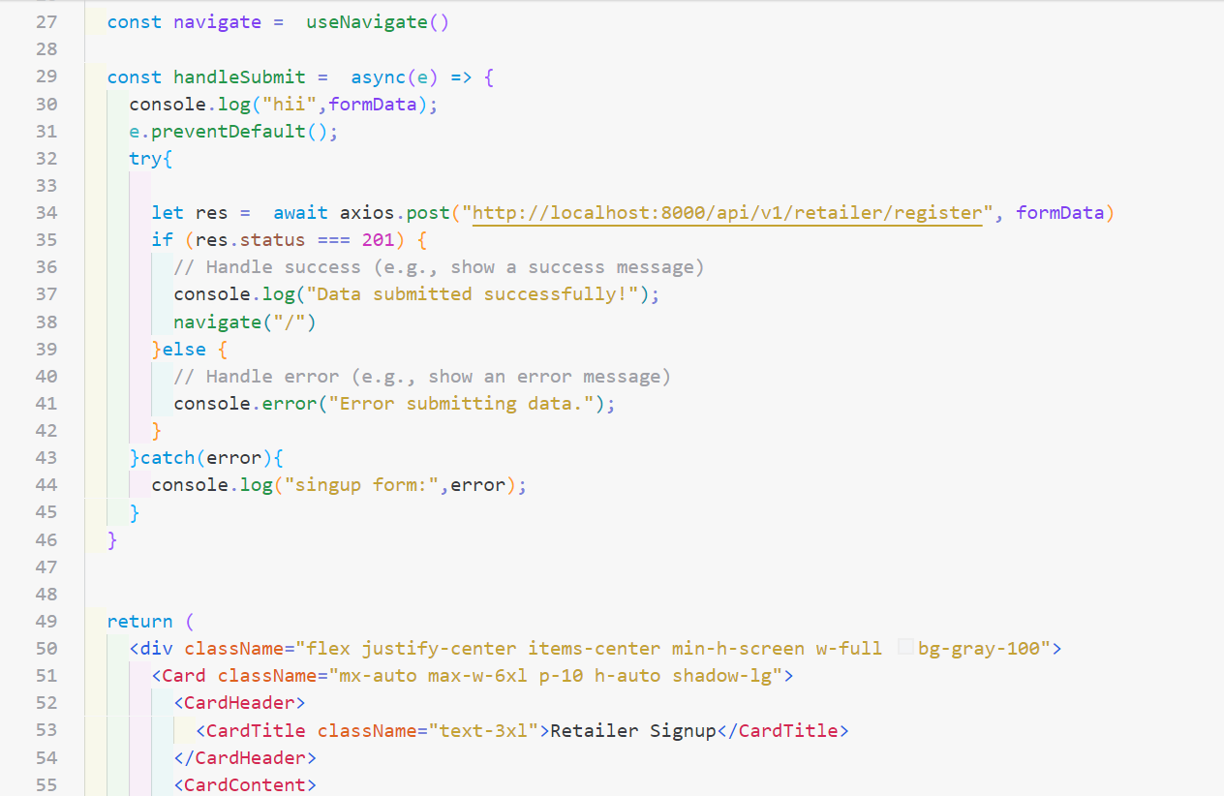 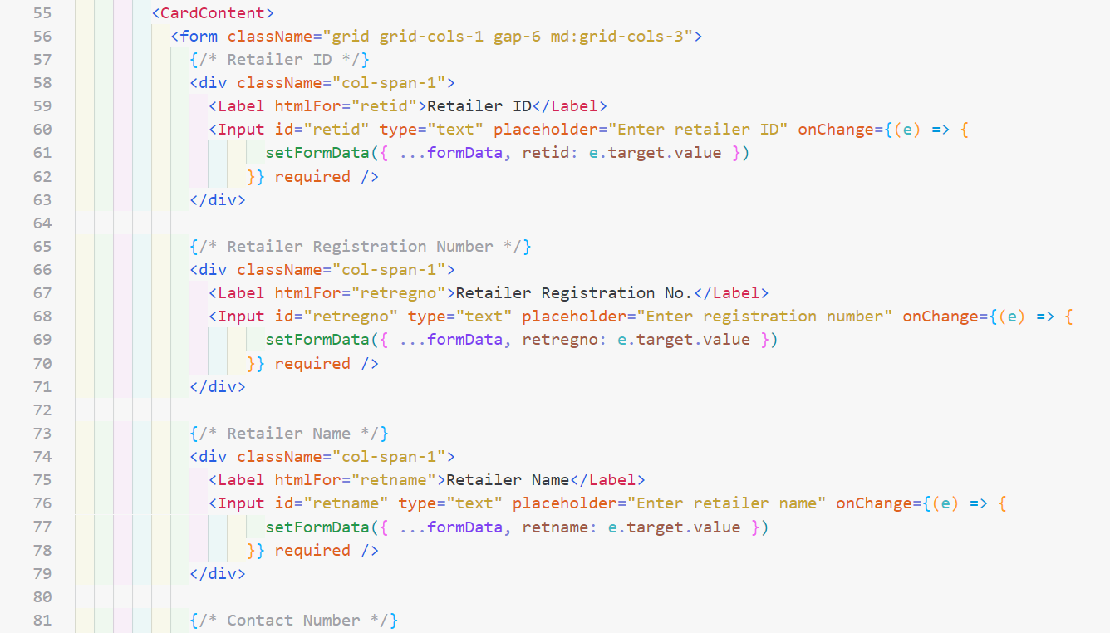 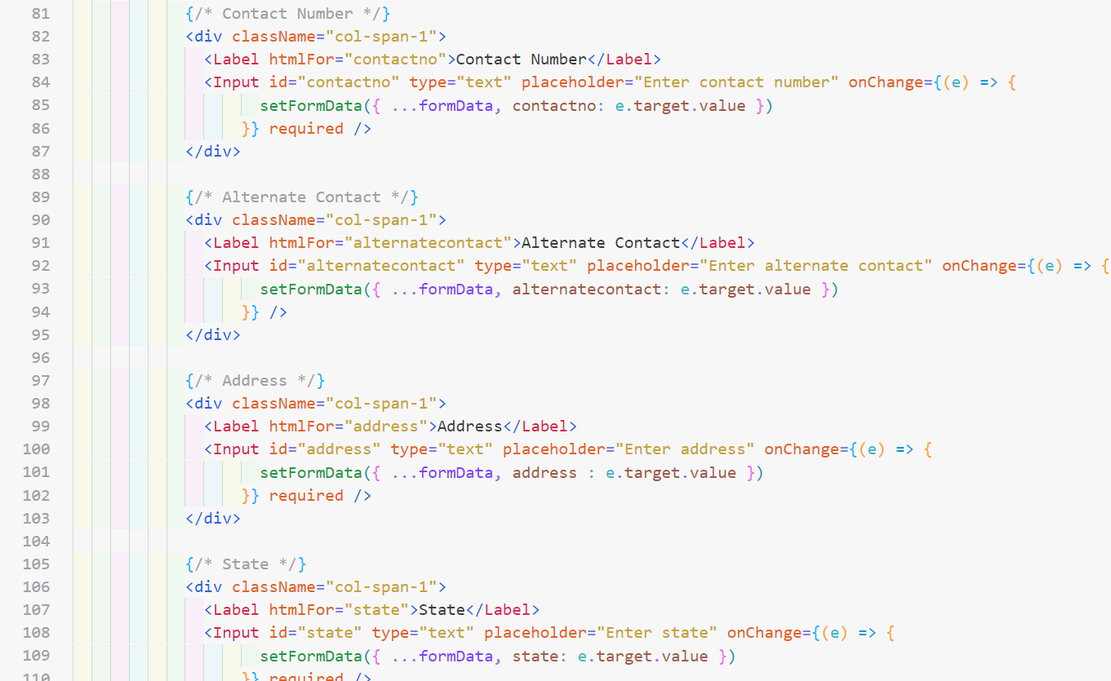 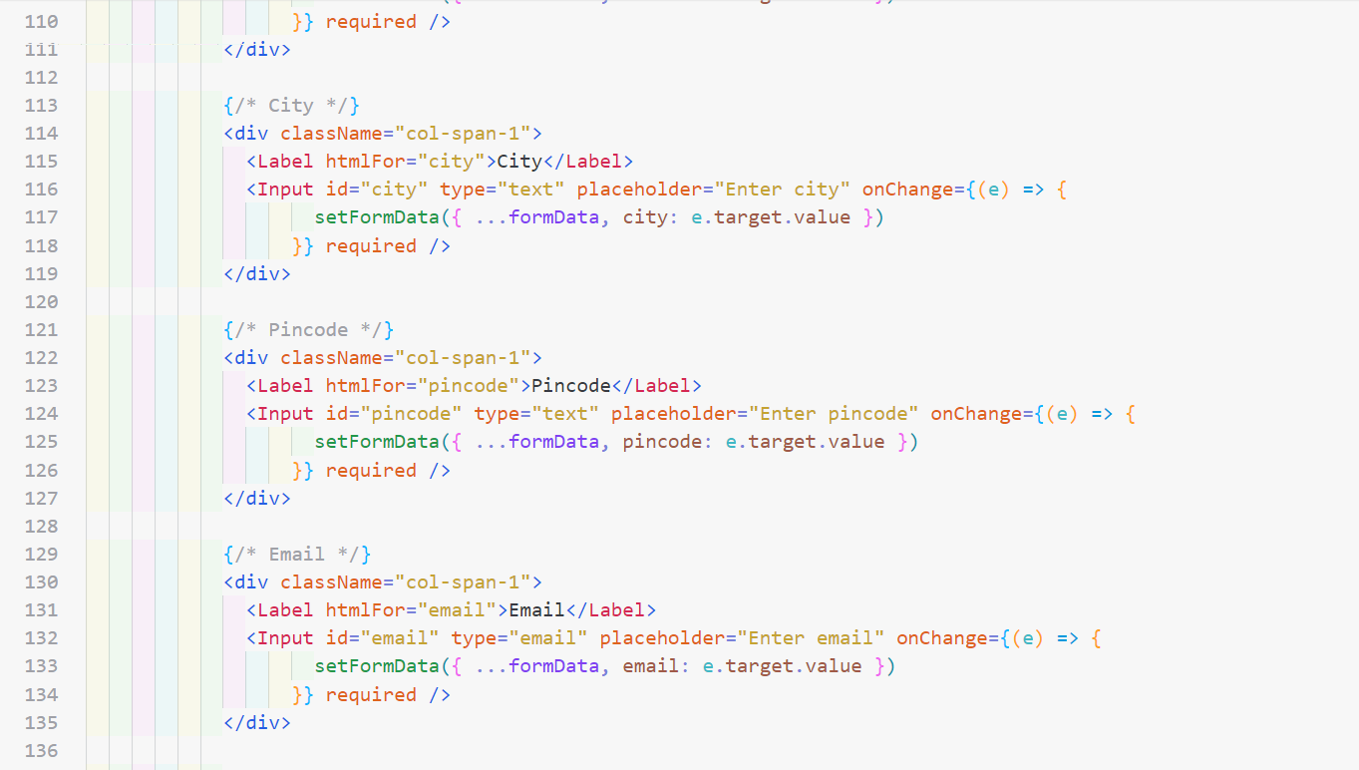 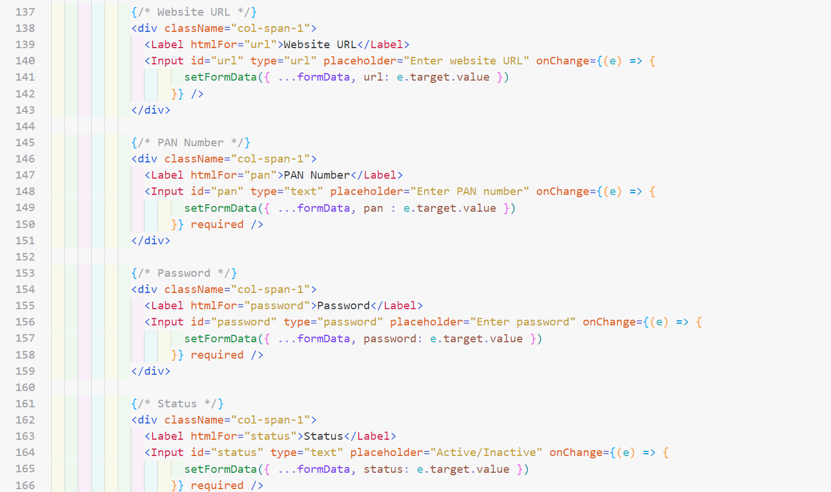 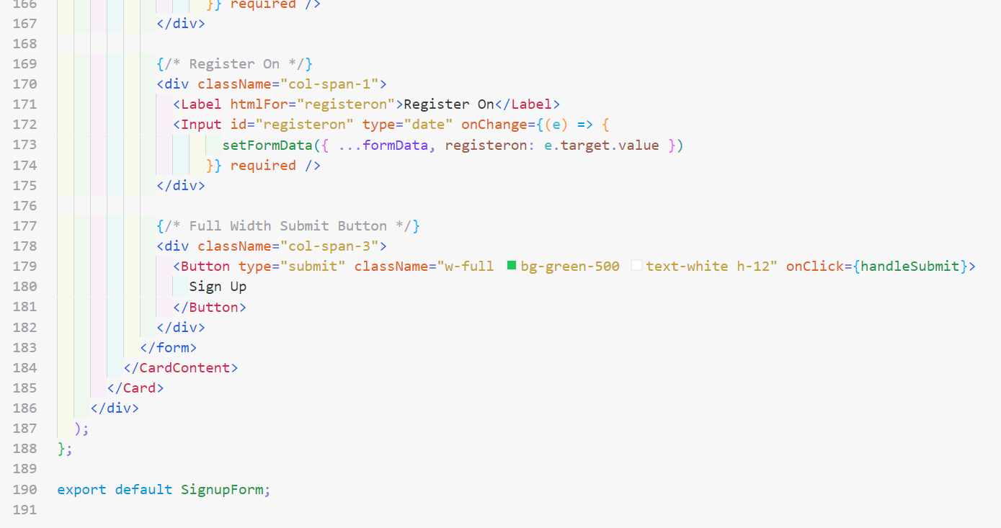

**Consumer Login Form**

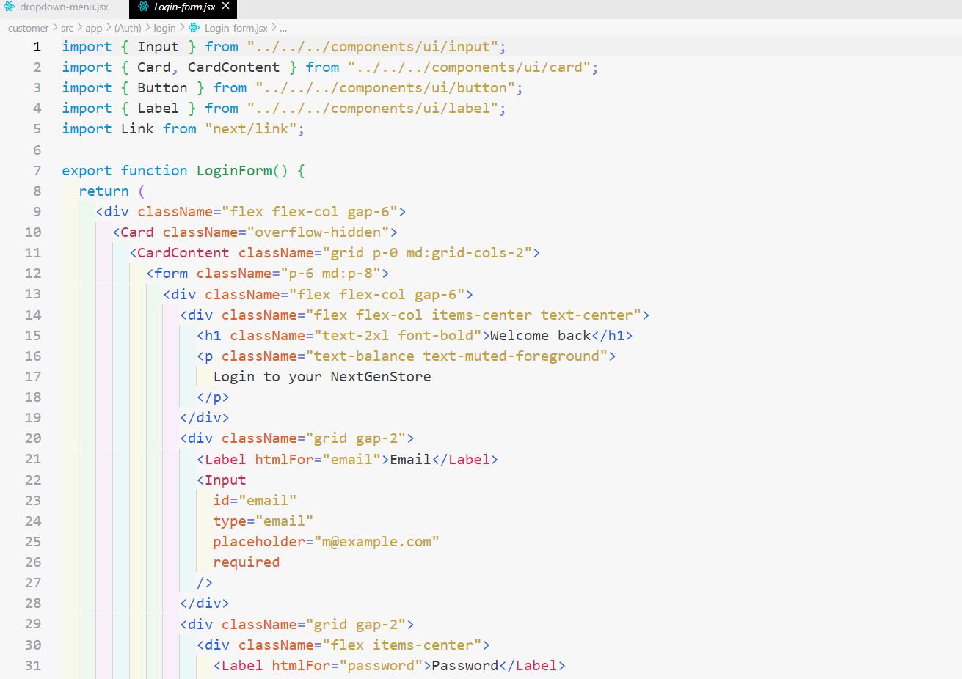 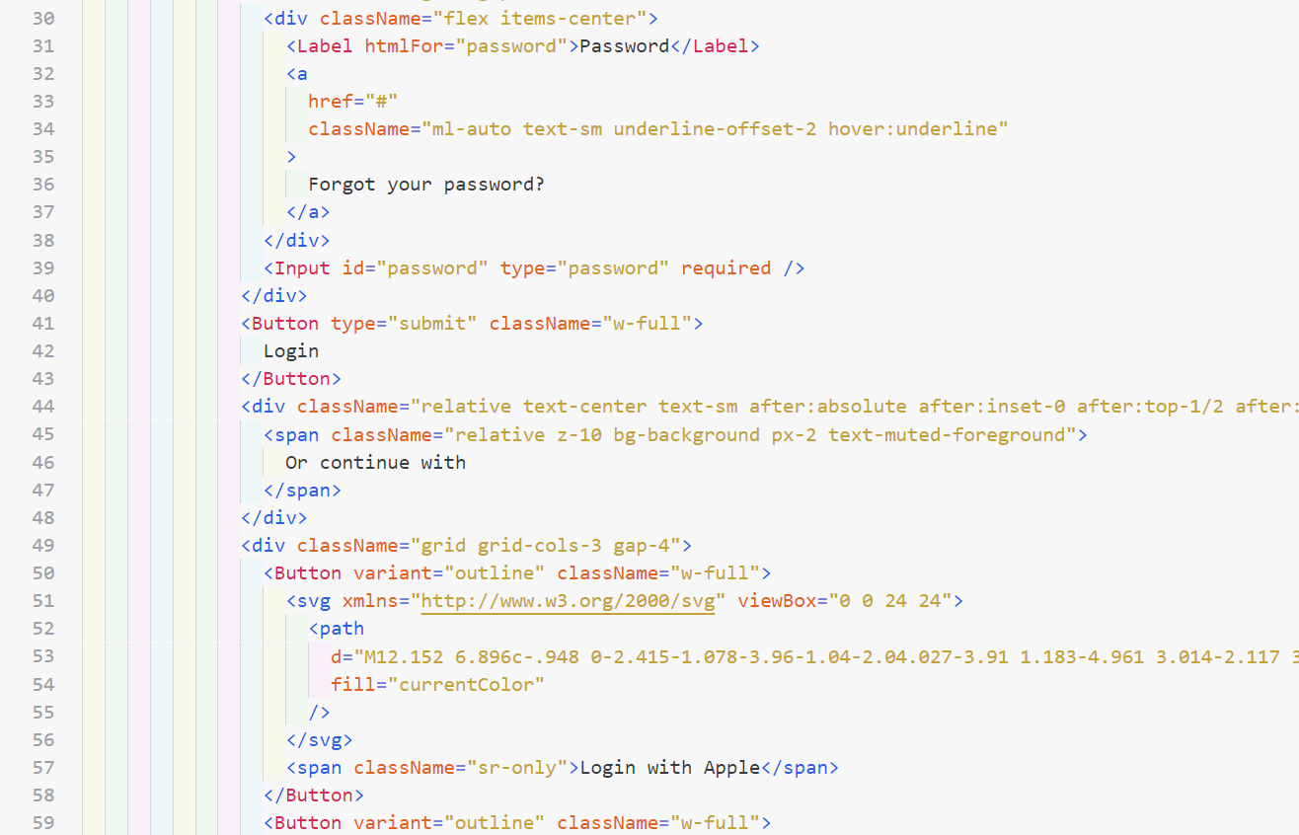 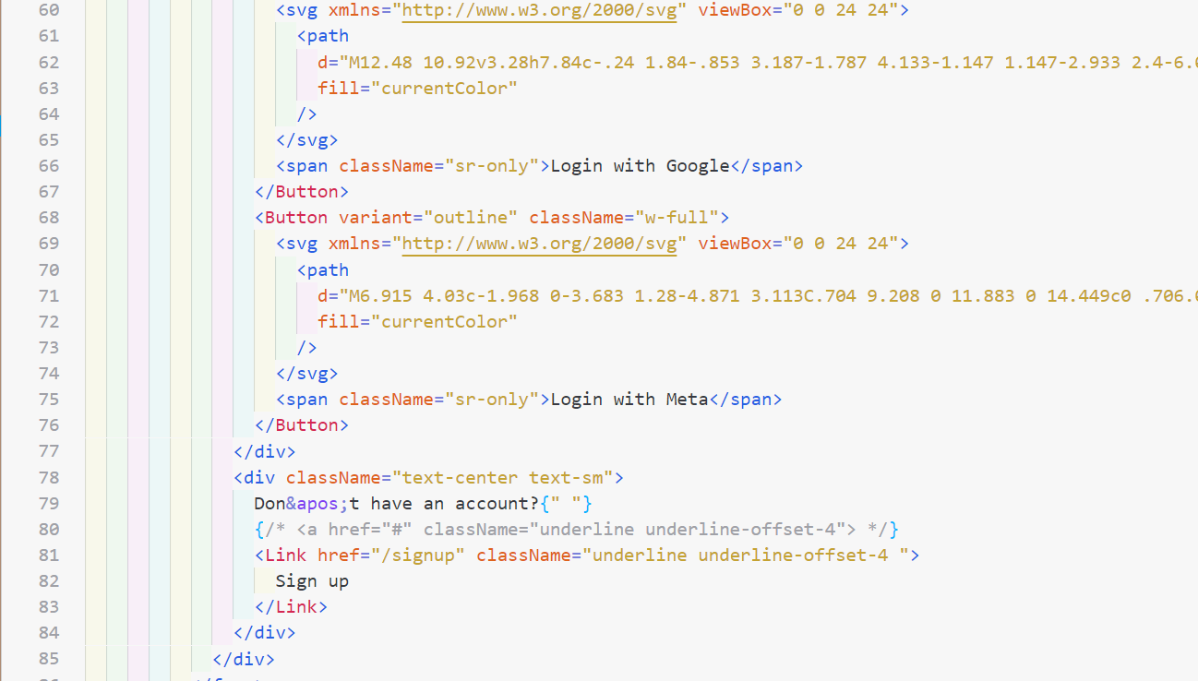 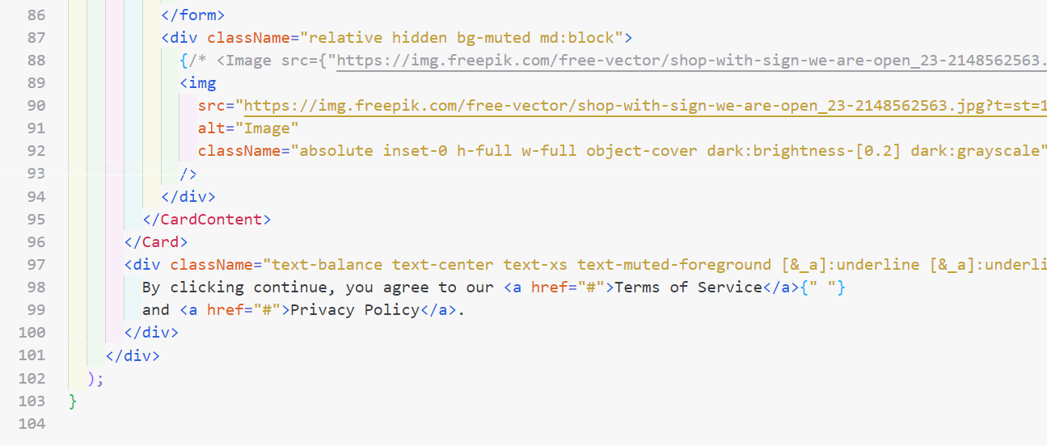

**Homepage Categories Page**

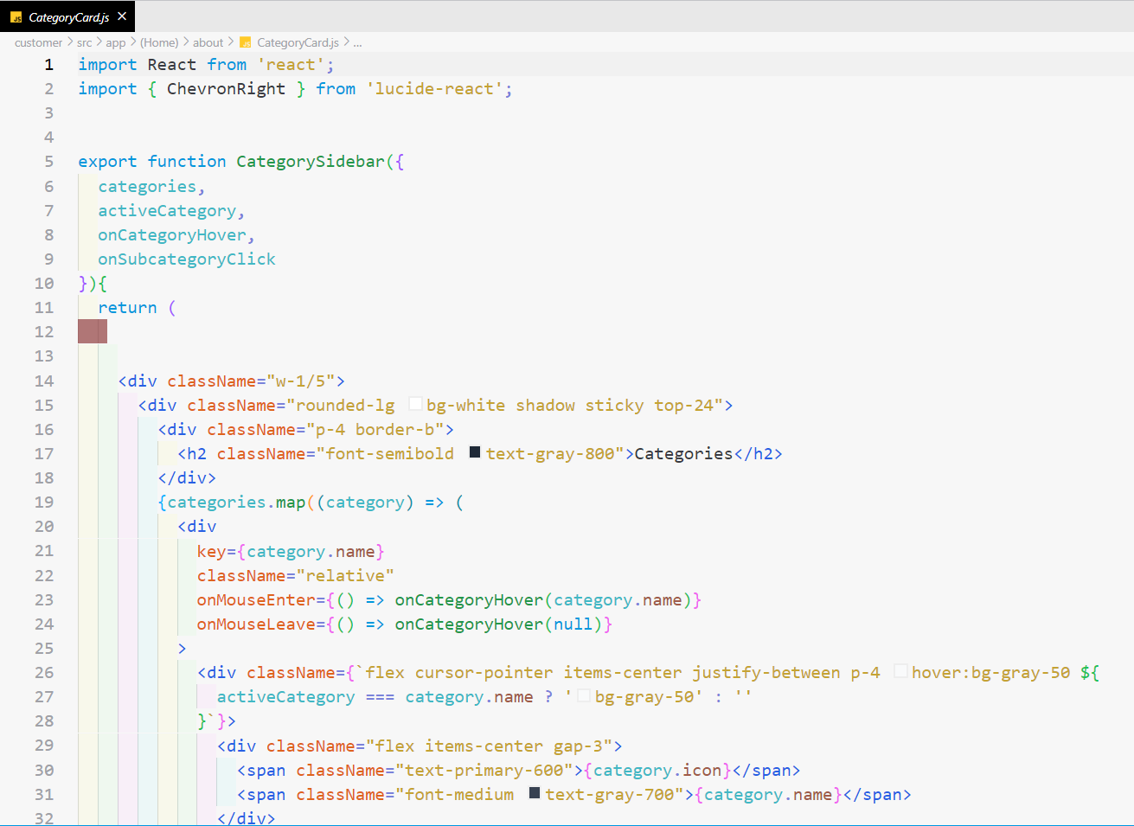 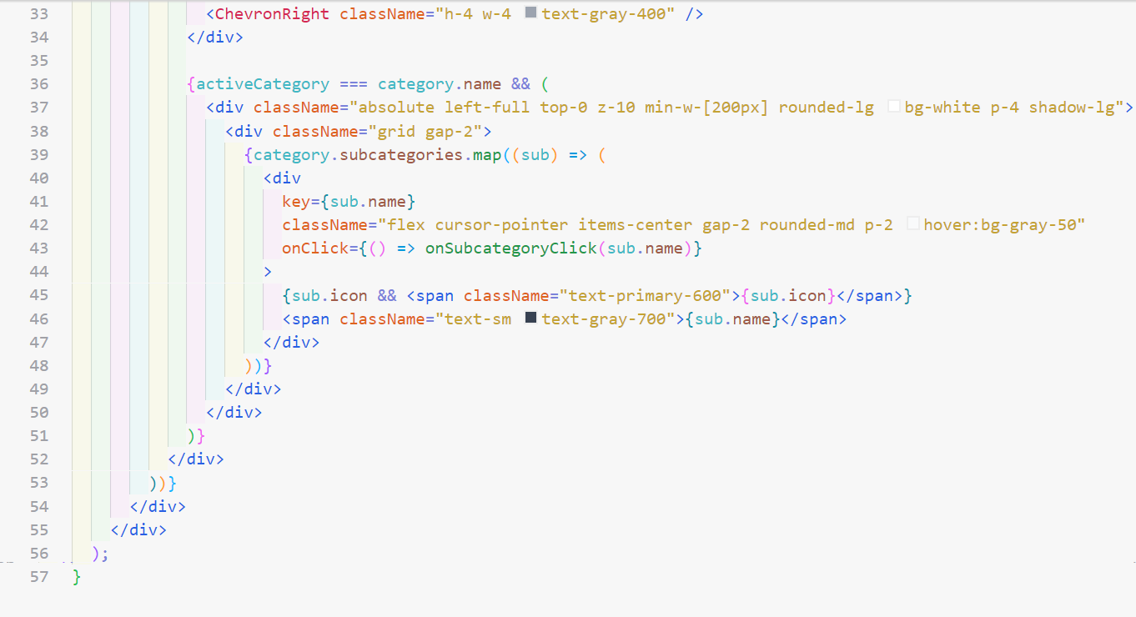

**Cart Item**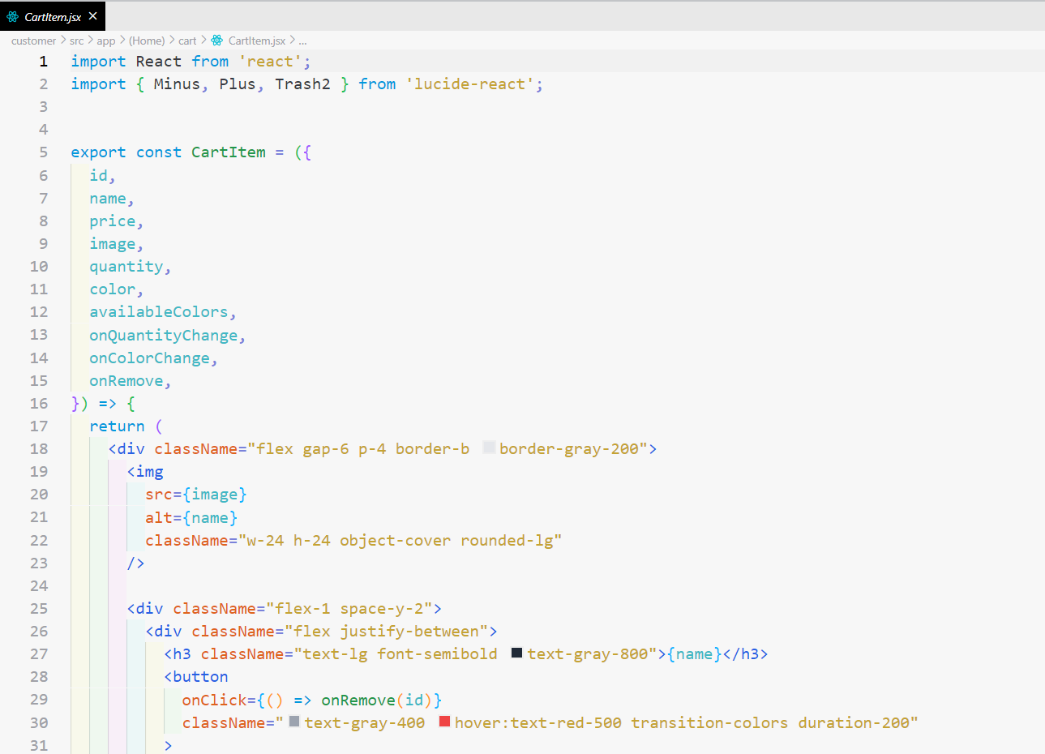 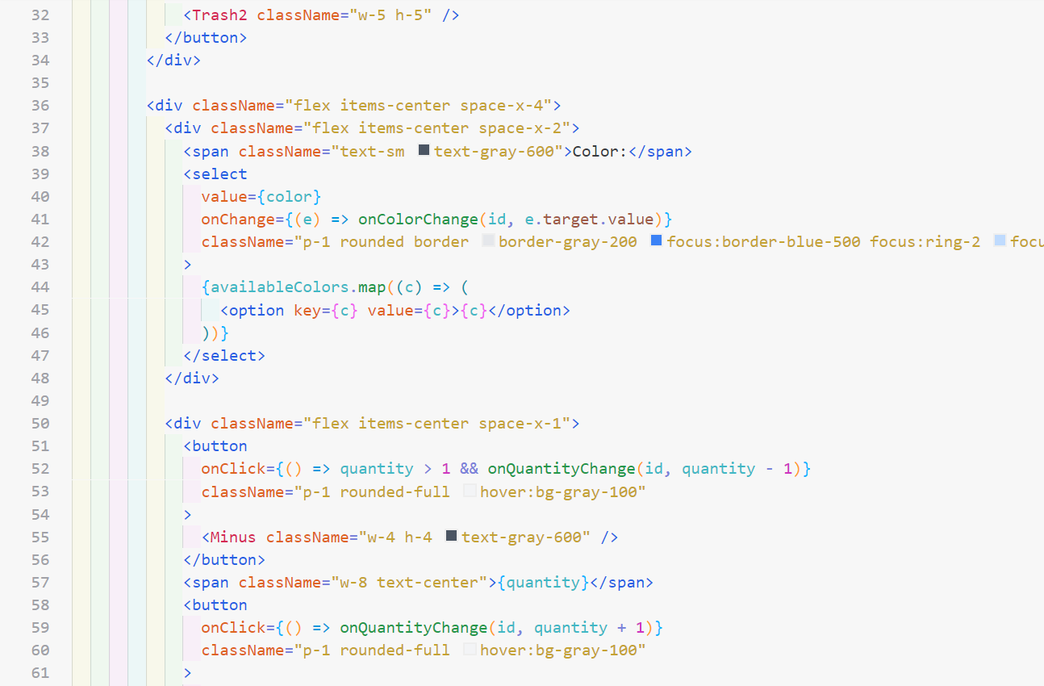 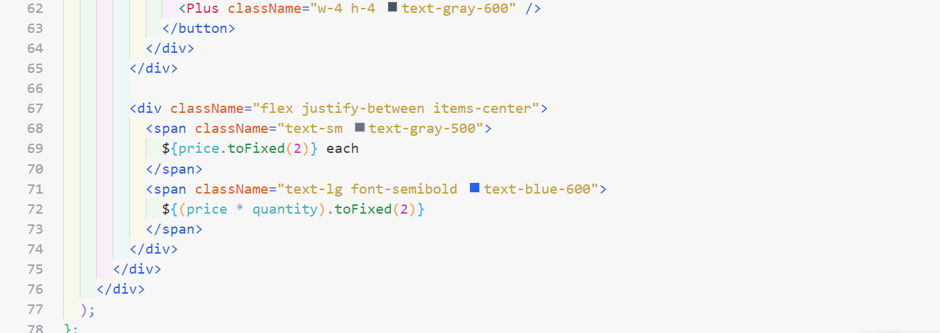

**Cart Page**

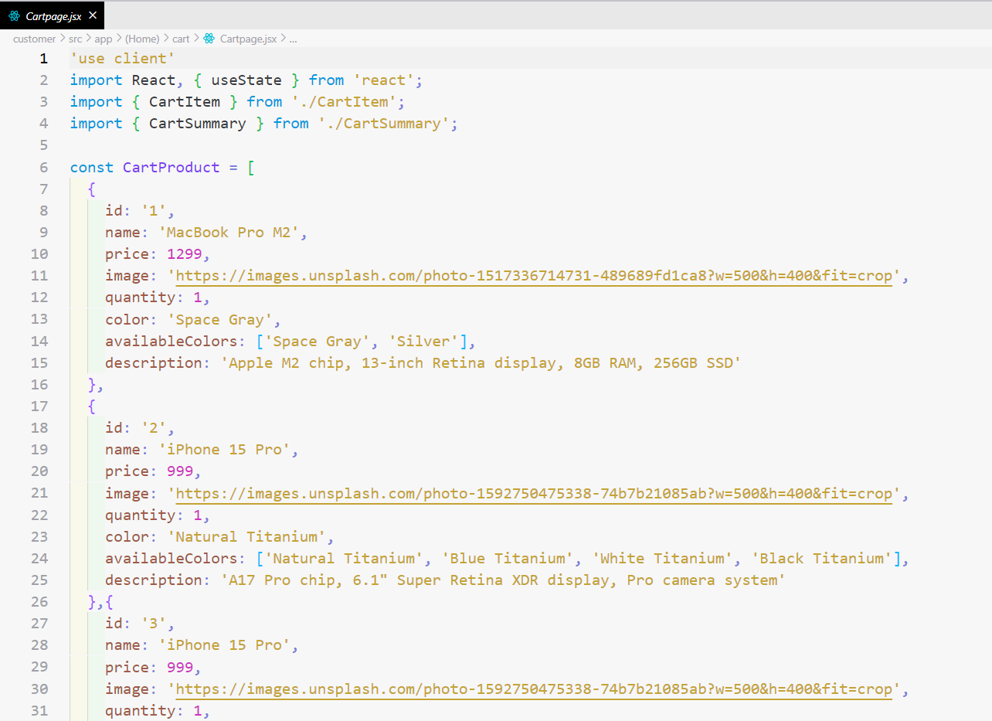 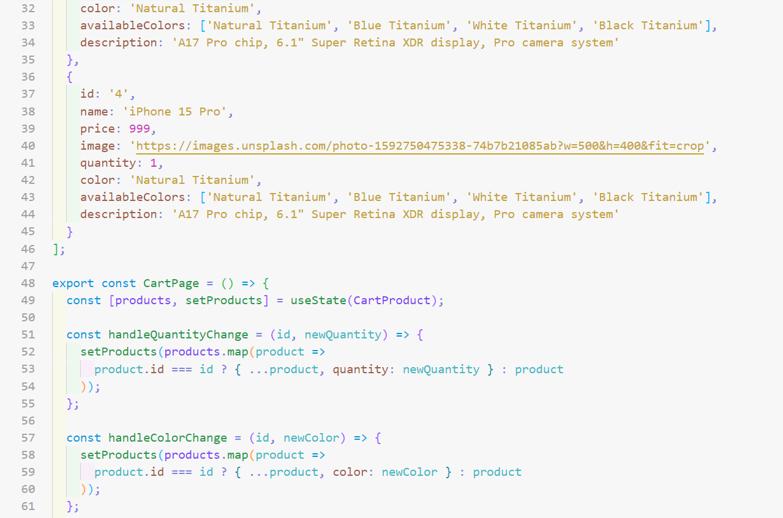 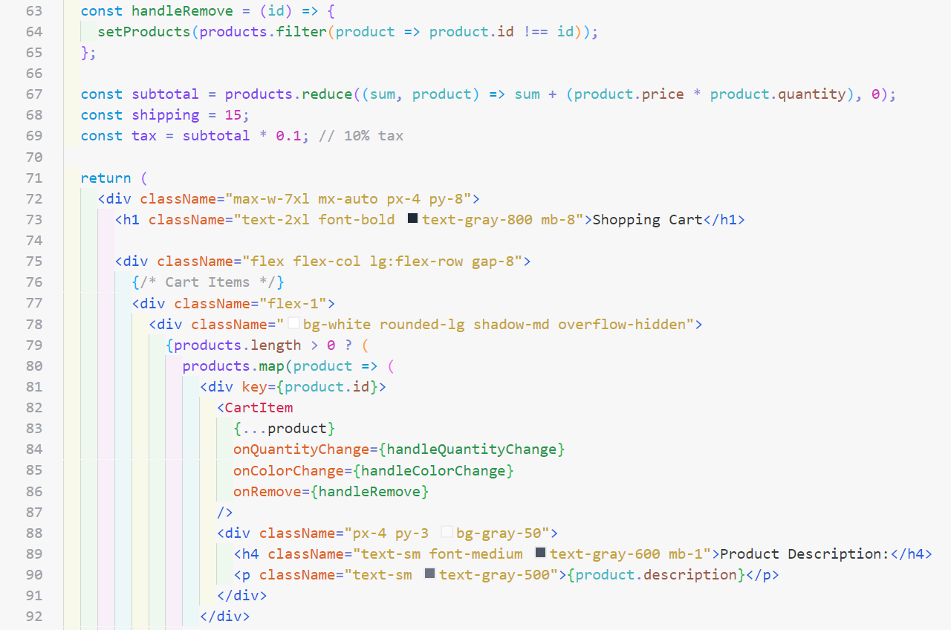 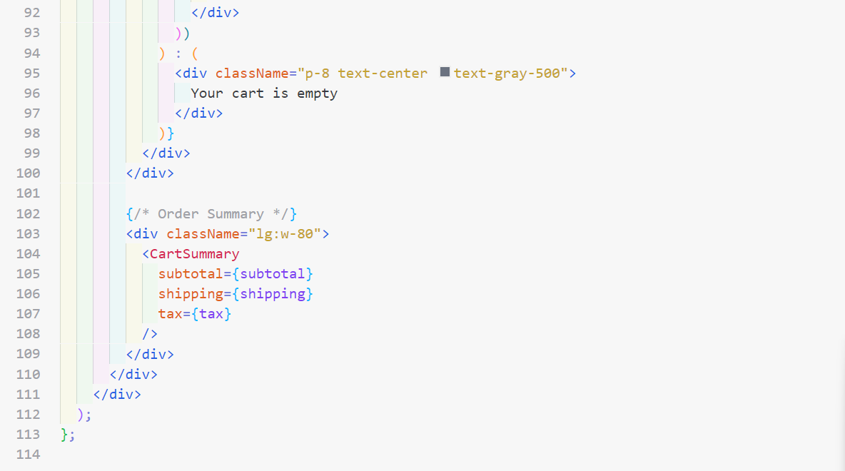

**Cart Summery**

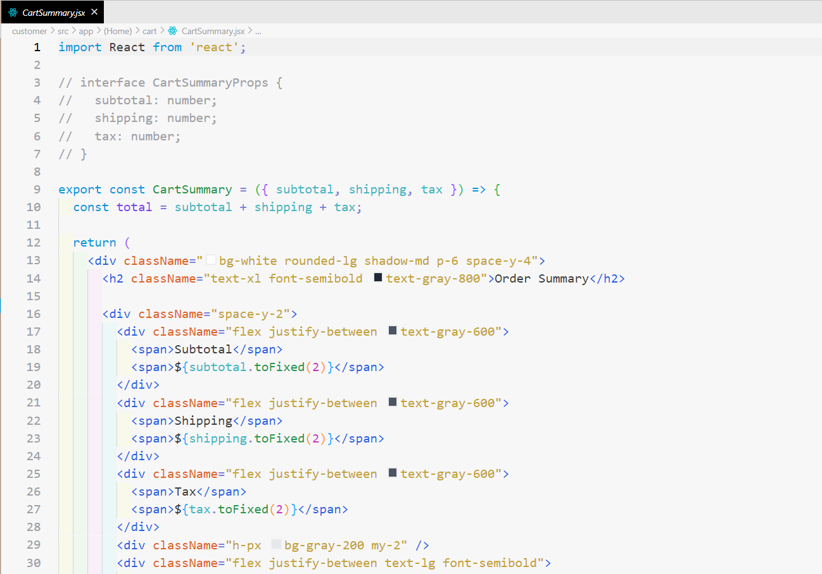

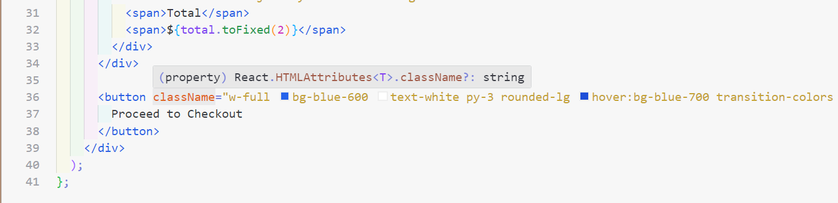

**NextGen Screenshot**

**Sign-Up Page**

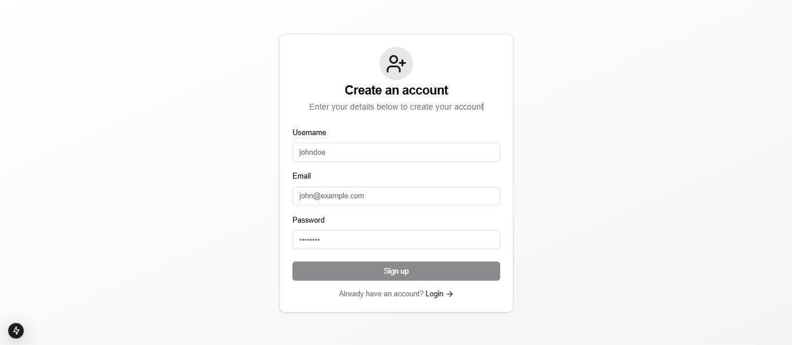

**Login Page**

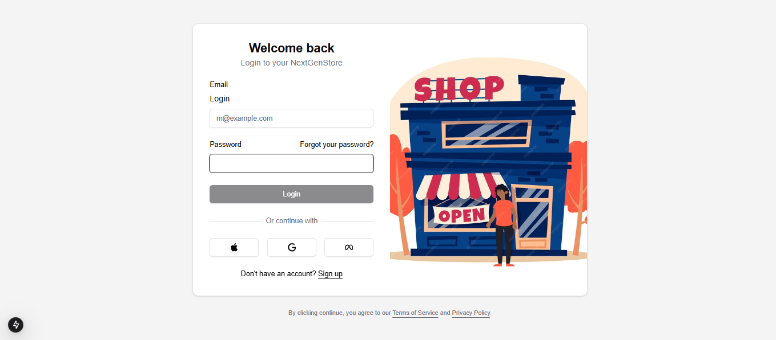

**Home Page**

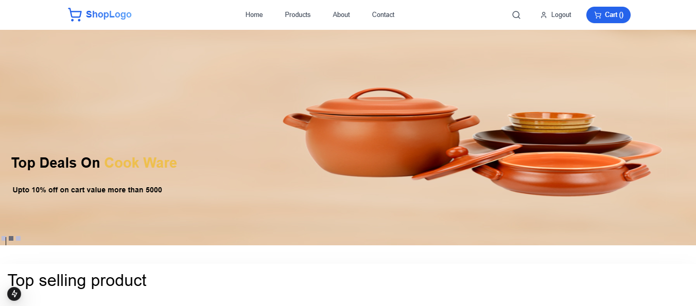

**Products Page**

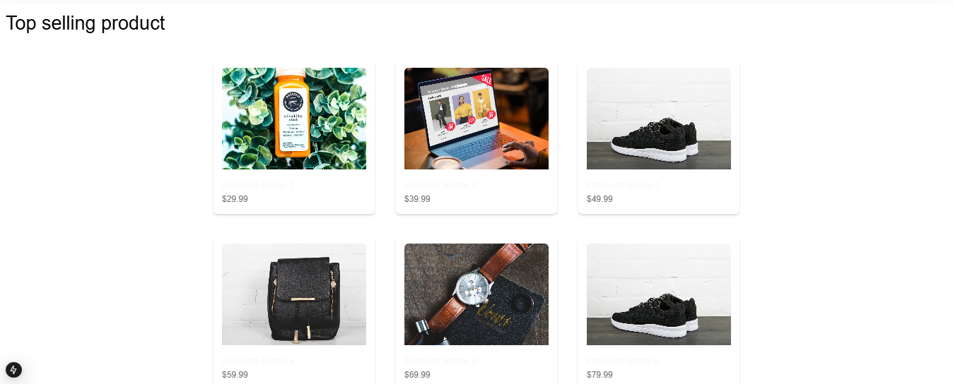

**Review Page**

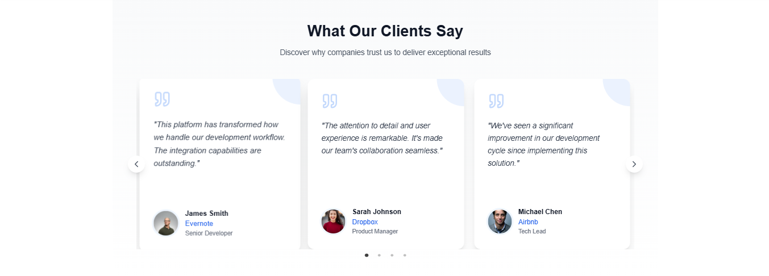

**Categories Page**

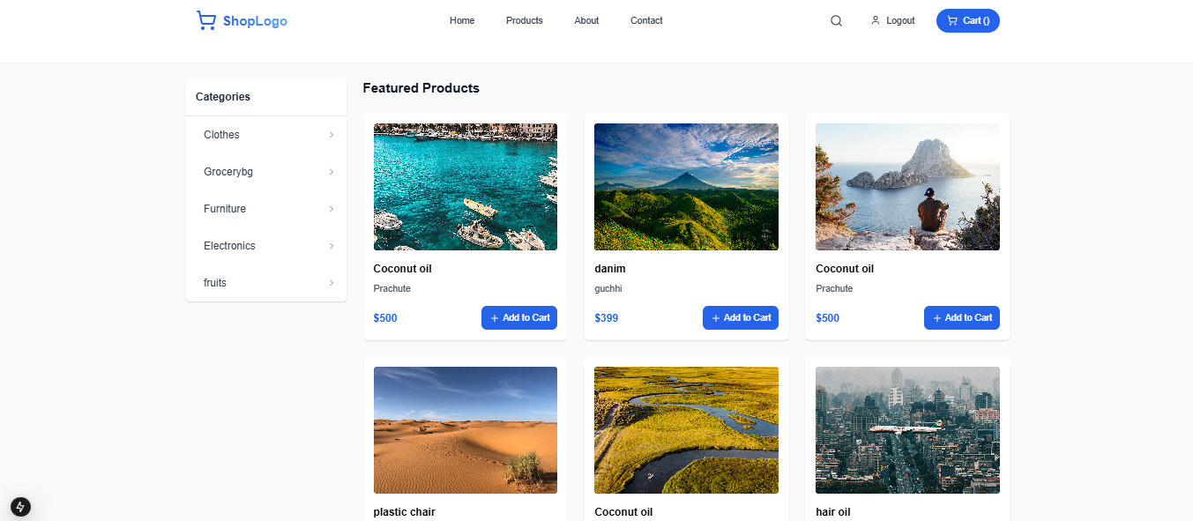

**Cart Page**

